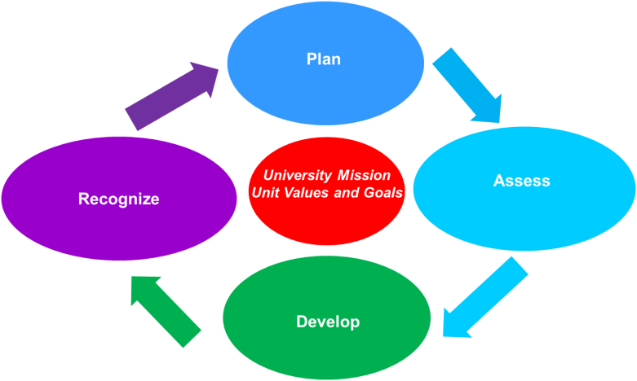
Performance Dialogue
Employee Name: | Click here to enter text.
University Title: | Click here to enter text.
Unit: | Click here to enter text.
Supervisor Name: | Click here to enter text.
Review Period: | Click here to enter text.

Employee and supervisor, separately complete the following questions to facilitate a dialogue and assess performance:
What was done well this last year? Share specific examples of achievements and accomplishments.
Click here to enter text.
Status of last year’s goals (please explain):
Click here to enter text.
What actions or changes might increase effectiveness? Share specific examples.
Click here to enter text.
Employee and Supervisor, separately complete this form by choosing from the dropdown lists below to evaluate how the Skills for Success, Job Specific Duties and Responsibilities, and depending on the role, the Leadership Skills for Success are demonstrated. Under Job Specific Duties & Responsibilities, add responsibilities specific to the individual’s role from their position description. See the “Rating Definitions” on the final page of this document. Please support your feedback with comments and examples. Performance Dialogue ratings are:
- Consistently Surpasses Expectations
- Frequently Exceeds Expectations
- Fully Achieves Expectations
- Needs Improvement
- Fails to Achieve Expectations

Skills for Success
Job skills | Choose an item. | Self-Development | Choose an item. | Service-Minded | Choose an item.
Inclusiveness | Choose an item. | Communication | Choose an item. | Stewardship | Choose an item.
Adaptability | Choose an item. | Teamwork | Choose an item. | Innovation | Choose an item.

Refer to and enter the key duties and responsibilities from the employee’s Staff Position Description (SPD) and provide feedback below.
Click here to enter text.
Job Specific Duties & Responsibilities
Click here to enter text. | Choose an item.
Click here to enter text. | Choose an item.
Click here to enter text. | Choose an item.
Click here to enter text. | Choose an item.
Click here to enter text. | Choose an item.
Comments:
Click here to enter text.
Leadership Skills for Success (optional for non-supervisors)
 | Creating Open and Inclusive Environment | Choose an item. |  | Problem Solving | Choose an item.
 | Exemplifying Interpersonal Effectiveness | Choose an item. |  | Delivering Results | Choose an item.
 | Planning & Decision Making | Choose an item. |  | Managing & Developing People | Choose an item.
Please give specific examples.
Click here to enter text.

To be completed by the supervisor and employee:

Overall Performance Level. Check One:

Fails to Achieve  Expectations * | Needs  Improvement * | Fully  Achieves Expectations | Frequently  Exceeds Expectations | Consistently  Surpasses Expectations
☐ | ☐ | ☐ | ☐ | ☐
*This rating requires a
conversation with HR.

Support your ratings with comments and examples.

Supervisor's Comments:
Click here to enter text.

Staff Member's Comments:
Click here to enter text.
Review Staff Position Description (SPD) for accuracy and understanding
The SPD accurately reflect the day to day duties and responsibilities of the job? (check one) ☐ YES ☐ NO
This PD includes documentation and discussion of the following. Check those that are completed.

Review of Staff Position Description (SPD) ☐
Review of previous year’s goals ☐
Set goals for next year (See “Employees Job Specific Goals” on page 4 of this document) ☐
Completion of the Career Development Plan ☐
Completion of the NCAA Addendum if it applies to the staff member’s position ☐

Actual date of initial meeting to discuss the Career Development Dialogue: Click here to enter text.

Immediate Supervisor: ________________________________________________ Date: Click here to enter a date.

Next Level Supervisor (optional): __________________________________________ Date: Click here to enter a date.

I have reviewed this document with my supervisor. My signature indicates that we have completed these discussions, but does not necessarily imply my agreement: any areas of disagreement are noted in my comments above (or in the attached document). I understand that I am entitled to receive a copy of this form and attachments, bearing all required signatures.

Staff Member: _______________________________________________________ Date: Click here to enter a date.

- - - - - - - - - - - - - - - - - - - - - - - - - - - - - - - - - - - - - - - - - - - - - - - - - - - - - - - - - - - - - - - - - - - - -
Rating Definitions
Cornell’s rating scale and corresponding definitions are below. Please use the Skills for Success, employee’s Job Specific Duties and Responsibilities,, and depending on the position, the Leadership Skills for Success to rate employees.

See the document titled “Characteristics of Performance Levels” for characteristics of individual performance levels within the Skills for Success.
Consistently Surpasses Expectations
Works consistently at a superior level in most aspects of position; consistently exceed goals and expectations. Makes an exceptional or unique contribution to the unit/department.

Frequently Exceeds Expectations
Performs beyond expectations in a majority of position duties and responsibilities. Proactively meets and predominantly exceeds position expectations – making a significant contribution to the overall achievement of unit/department goals.

Fully Achieves Expectations
Reliably performs position duties and responsibilities. Fulfills position requirements, established goals and expectations. Solid performance results in valuable contributions to unit goals.

Needs Improvement
Fails to meet one or more of the significant position requirements. Requires improvements in areas noted. Performance improvement plan must be developed and monitored.

Fails to Achieve Expectations
Does not fulfill position requirements. Performance Improvement Plan (PIP) must be developed and monitored; or termination must be initiated.

Employee’s Job Specific Goals: Please identify next year’s goals in alignment with the departmental objectives.

Projected Date of Completion of Goal Development: Click here to enter a date.

FYClick here to enter text. Goal 1 | Click here to enter text.
Objective | Click here to enter text.
Accountable | Click here to enter text.
Actions/  Tactics | Click here to enter text.
Deliverable | Click here to enter text.

FYClick here to enter text. Goal 2 | Click here to enter text.
Objective | Click here to enter text.
Accountable | Click here to enter text.
Actions/  Tactics | Click here to enter text.
Deliverable | Click here to enter text.

FYClick here to enter text. Goal 3 | Click here to enter text.
Objective | Click here to enter text.
Accountable | Click here to enter text.
Actions/  Tactics | Click here to enter text.
Deliverable | Click here to enter text.

Goals Check In: Please check in on progress toward the established goals at 6 months. Indicate the status and any additional information needed. Also, note other accomplishments and how they relate back to individual or unit goals.
6 Month check-in: / / | Completed | In Process | Not Completed | Comments
- Click here to enter text. | ☐ | ☐ | ☐ | Click here to enter text.
- Click here to enter text. | ☐ | ☐ | ☐ | Click here to enter text.
- Click here to enter text. | ☐ | ☐ | ☐ | Click here to enter text.
Please note any other accomplishments not listed above and/or how these contributed to individual or university goals.
Click here to enter text.

NCAA Addendum – Only complete the following if your position requires adherence to NCAA guidelines:
Staff: Please check box and provide signature and date below.
  ☐  By signing below, you acknowledge that you are required to conduct business in compliance with NCAA and Ivy League rules and regulations and that you have reported any knowledge of violations involving yourself or your institution to the appropriate individuals on campus.

Staff Member: ___________________________________________ Date: Click here to enter a date.
Supervisors: Please complete the following:
  ☐ By signing below, you certify that you have assessed the staff members’ adherence to NCAA and Ivy League rules and regulations and that, to the best of your knowledge, the staff member has operated in compliance with such rules and regulations.

Supervisor: _____________________________________________ Date: Click here to enter a date.

